**Project Report: Hotel booking website (LuxeStay)**

**Finalization Phase**

**Introduction**

The hotel booking web service effectively utilizes modern web technology to provide users with an easy way to view, select and reserve hotel accommodation. Online booking platforms have revolutionized the hospitality industry, providing users with convenience, variety, transparency and security. In this project we have tried to solve one of the problems which users face while booking for a hotel. We have provided all the features which the hotel booking website should have. We also focused on the user’s convenience to improve the user experience. Our main motive behind this project is to revolutionize the online booking of the hotels. We have enabled the user to look for a room on the various categories such as single room, double room etc. Various price range, various services which are optional. If the user wants to have that he can add it while booking otherwise he can skip that. This is done because just to make sure that all the user can make the booking from person with low income to rich class everyone.

**Technical Approach**

To build this hotel booking website we have used the technologies such as: HTML, CSS, Javascript , PHP and MySQL. HTML is used to build the main structure of the website it also serves as the skeleton of the website. Whereas CSS is used to décor the website, each and every elements can be customized accordingly with the help of the CSS. It is very important because it provides the good look to our website and it also increases the overall user experience. Javascript is used to add the interactivity to the website such as animation, validation and also to perform some actions based on the user input. This is again is very important to increase the user experience. PHP is a scripting language used to interact with our database it will help us adding or storing the information in the database and also to retrieve the information from the database. MySQL is a database which is used to store all the data in it. It is a relational database which uses the relationship to link between the tables.

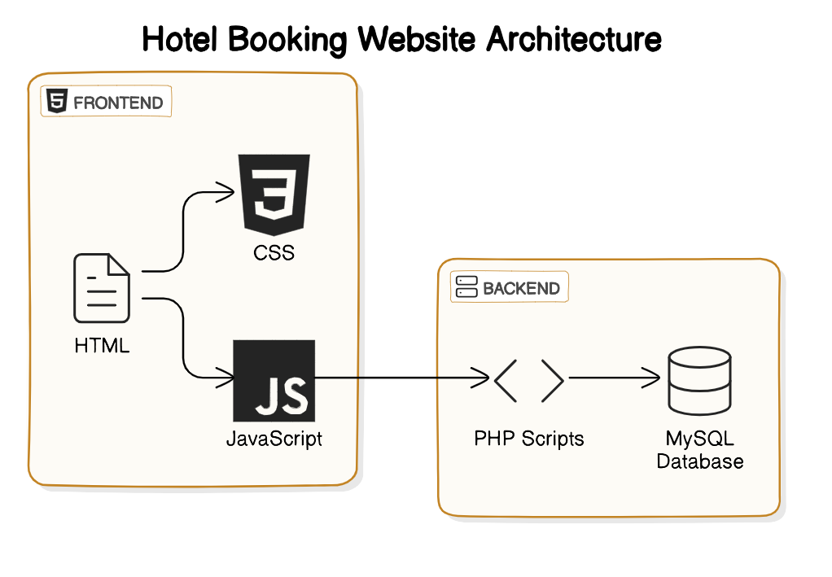

# Component Interaction and Communication:

# The user is first landed to login page to sign in if he doesn’t has the account then he can create one and once the sign up is done he will be taken back to login page where he has to enter the login credentials to login. Once the login is complete, then he will be navigated to the main page where he can view all the rooms available and if he want to book that room he can easily do that by filling the details in the booking form and if he has any kind of doubt or confusion then he can leave a query in the contact form. When he is booking the room he need to provide the details like the basic details( name, phone etc) and also from when to when he has to specify the time line that how long he will be there.

# diagram-export-4-25-2024-6_57_01-PM.png

**Usage**

**1. User Section:**

**Login Page/Signup Page:**

* This window allows the user log in into his or her account. New users can create an account by clicking on the “Sign Up” button. Follow instructions displayed to properly create a new user.

**Home Page:**

* This is the page where user can view all the rooms which are available. Can see the information such as short info about the company and also a contact form for any kind of query.
* He can also book the rooms by clicking on the “book” button then the pop up will be opened where he need to add all the details.
* Once the booking is successful then a success message is shown to him or if the booking is unsuccessful then the message will be shown saying that, the booking was unsuccessful.

**Logout:**

* User also has the logout button which he can use it in order to logout from the website. Once the user is logout then he needs to login again.

**2. Admin Section**

**Login Page/Signup Page:**

* This window allows the admin log in into his or her account. This is important because it is essential to make it secured as it has a complete modification of the website.

**Dashboard Page:**

* This is the page where admin can view all the booking request which he needs to approve so that the booking is completed is successfully.
* He can also add the staff member in the system. And even the new rooms in the systems which then are visible to the users.
* All the information will be visible to him including the room booking, query made by the user and also the rooms status.
* He can also generate the bills or invoices from here.

**Logout:**

* Admin also has the logout button which he can use it in order to logout from the website. Once the user is logout then he needs to login again.

**Challenges and Pitfalls:**

Through the challenges and learning experiences encountered during the development of the Hotel booking website, my understanding of website development and problem-solving has significantly deepened. The initial and most daunting phase involved conceptualizing and architecting the website. Every conceivable variable and potential obstacle had to be foreseen and meticulously addressed. This entailed decision-making on the requisite number of classes, defining their functionalities, and establishing seamless interactions between them.

**Conclusion**

The system which we have developed is to solve one of the major problems which is faced by many people. With the help of our system we try to solve that problem. And day by day all the sectors are being revolutionized including the hotel or lodging sector we are trying to contribute on to that revolution. We came up with a web solution that help both the hotel staff and also the normal users making it easy for them to book the hotel and view all the options they have where as it is helpful for hotel staff as it is more convenient to handle.